EXPERIMENT-3

AIM: TO ADD HEADER, FOOTER AND CSS TO EXISTING HOMEPAGE.

HEADER:

The <header> element represents a container for introductory content or a set of navigational links.
A <header> element typically contains:
- one or more heading elements (<h1> - <h6>)
- logo or icon
- authorship information
You can have several <header> elements in one document.
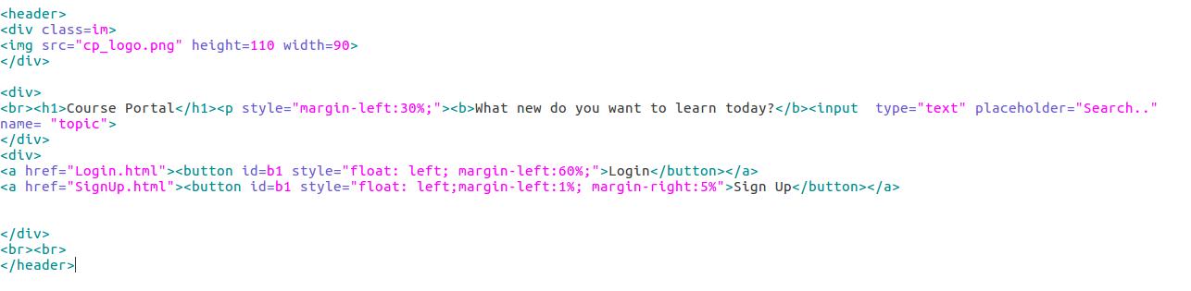
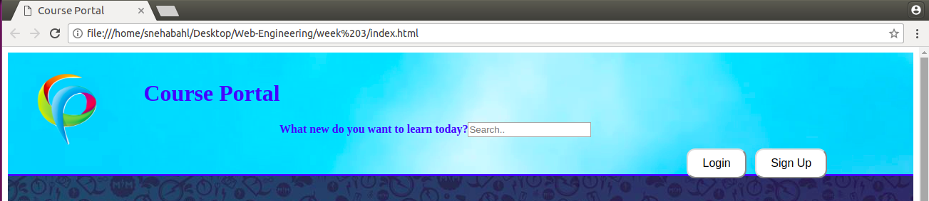
FOOTER:

The <footer> tag defines a footer for a document or section.
A <footer> element should contain information about its containing element.
A <footer> element typically contains:
- authorship information
- copyright information
- contact information
- sitemap
- back to top links
- related documents
You can have several <footer> elements in one document.

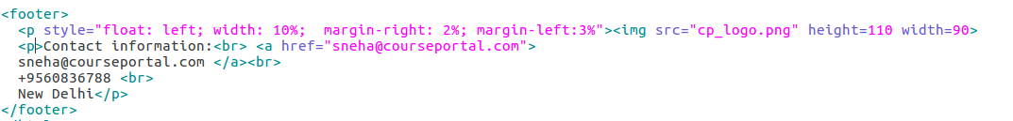

CSS:

CSS stands for Cascading Style Sheets
- CSS describes how HTML elements are to be displayed on screen, paper, or in other media
- CSS saves a lot of work. It can control the layout of multiple web pages all at once
- External stylesheets are stored in CSS files.

